Information Security

Project Report

21i-0342 Eesha Khan

21i-0338 Abdullah Bin Naeem
Post-Quantum Cryptography App

Description of PQC Algorithm Used

The initial goal of this project was to implement a Post-Quantum Cryptography (PQC) algorithm using the liboqs-python library, which provides access to quantum-resistant cryptographic algorithms such as those based on lattice cryptography (e.g., Kyber or Dilithium). PQC algorithms are designed to be secure against attacks from both classical and quantum computers, particularly those leveraging Shor's algorithm to break traditional asymmetric algorithms like RSA and ECC.
However, due to compatibility issues with liboqs-python on Windows, the project pivoted to using the cryptography.fernet library for symmetric encryption. Fernet implements a secure symmetric encryption scheme based on AES (Advanced Encryption Standard) in CBC (Cipher Block Chaining) mode with 128-bit keys, combined with HMAC (Hash-based Message Authentication Code) using SHA256 for authenticity. While Fernet is not a post-quantum algorithm, it provides a robust and practical symmetric encryption method for this demonstration. Fernet ensures confidentiality through AES encryption and integrity through HMAC, making it suitable for securely encrypting and decrypting messages in this web application.
In a production environment aiming for post-quantum security, a hybrid approach could be adopted, combining symmetric encryption (like Fernet) with a PQC key exchange mechanism (e.g., Kyber from liboqs-python) to securely distribute the symmetric key. This project demonstrates the foundational concepts of key generation, encryption, and decryption, which can be extended to incorporate true PQC algorithms once compatibility issues are resolved.

App Screenshots

Main Page
The main page showcases the updated design with a futuristic theme, including a gradient background, neon-blue accents, and cards for key generation, encryption, and decryption.
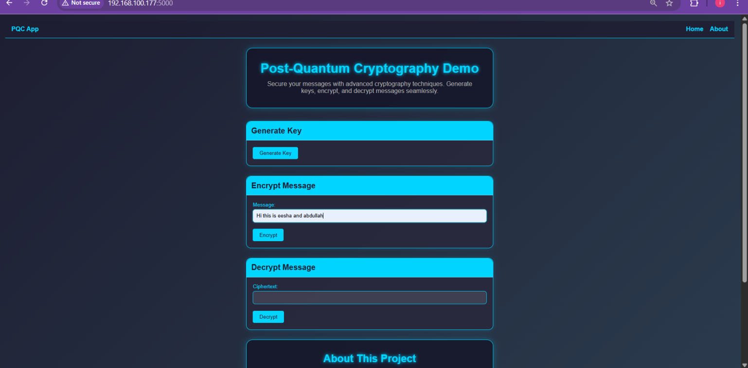

Encryption Result
After generating a key and encrypting a message, the result is displayed. Note: Due to a rendering issue, the result page currently displays as plain text.
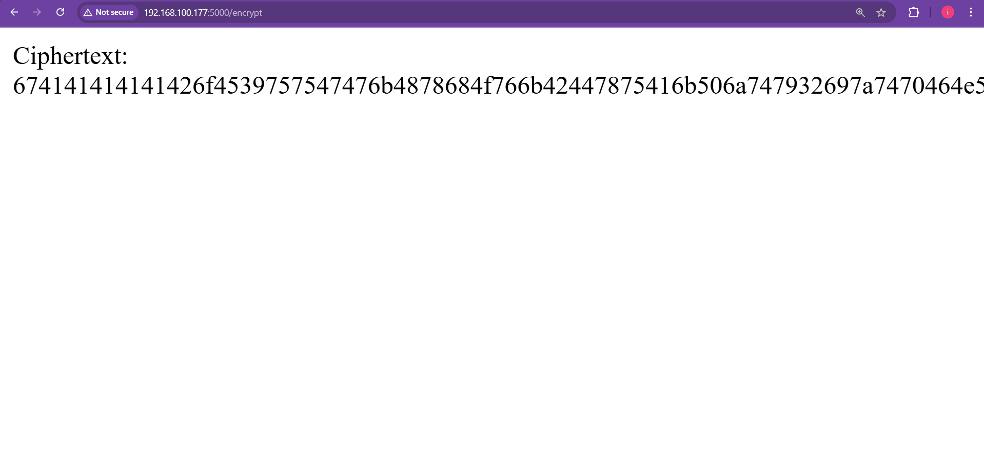

Decryption Result

After decrypting the ciphertext, the original message is displayed. Note: Due to a rendering issue, the result page currently displays as plain text.
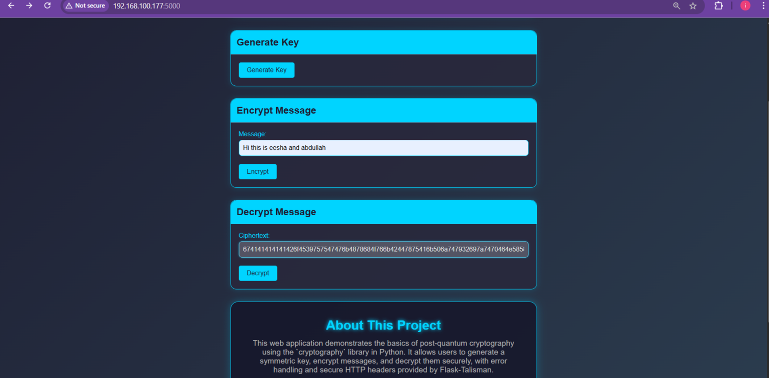
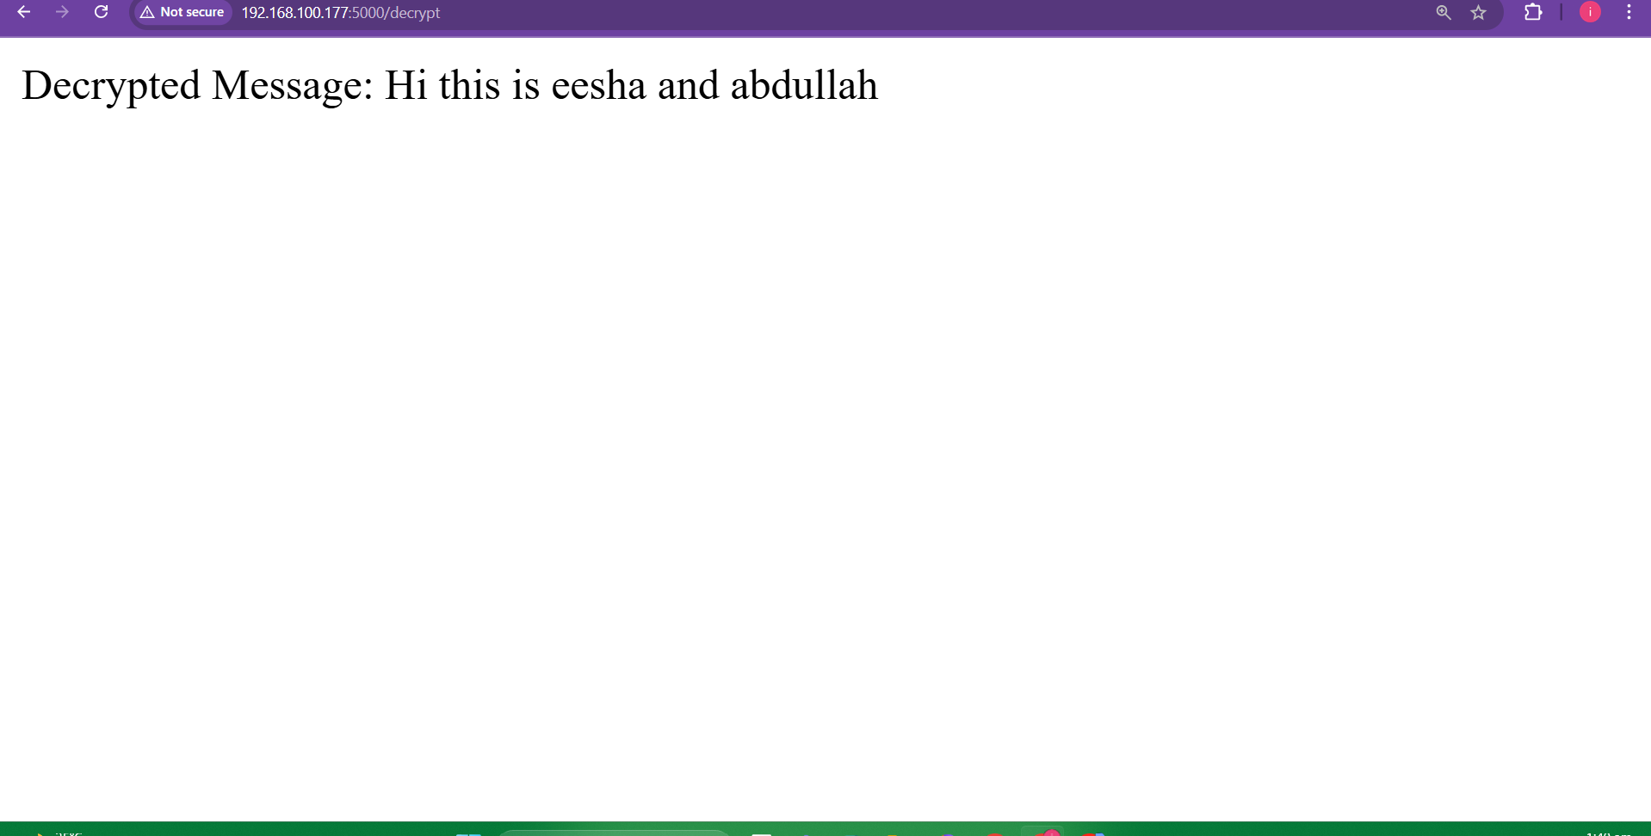

Error Handling
Attempting to decrypt without generating a key results in an error message. Note: Due to a rendering issue, the result page currently displays as plain text.
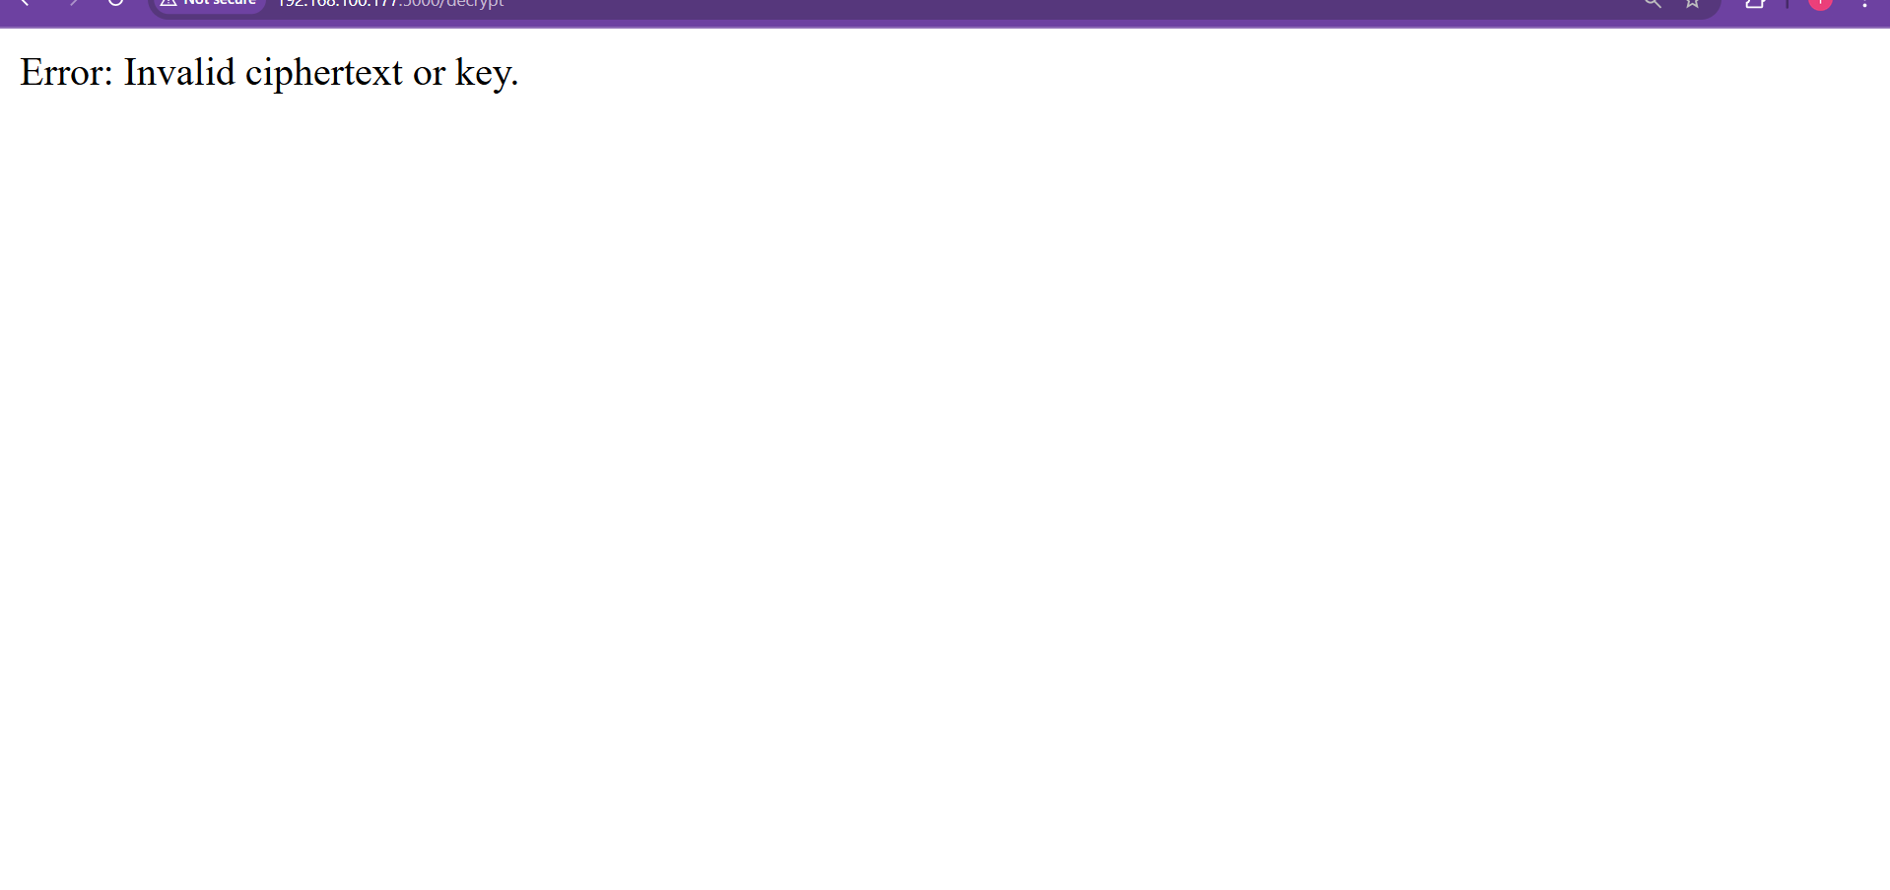

Working Explanation
This web application demonstrates a simplified symmetric encryption workflow using the cryptography.fernet library. Below is an explanation of the key generation, encryption, and decryption processes, along with notes on the current rendering issue.

Key Generation
- Route: /generate_keys (POST)
- Process:
  - When the user clicks the "Generate Key" button on the main page, a POST request is sent to the /generate_keys route.
  - The Fernet.generate_key() method generates a random 256-bit key suitable for use with Fernet encryption. This key is a URL-safe base64-encoded string.
  - The key is stored in the Flask session (session['key']) to be used for subsequent encryption and decryption operations.
  - The user is redirected back to the main page (index.html) with a refreshed session.
- Purpose: The key serves as the symmetric key for both encryption and decryption, ensuring that only users with the key can decrypt messages.

Encryption
- Route: /encrypt (POST)
- Process:
  - The user enters a plaintext message in the "Encrypt Message" form and clicks "Encrypt," sending a POST request to the /encrypt route.
  - The route checks if a key exists in the session. If not, it returns an error message ("Error: Please generate a key first.").
  - The plaintext message is retrieved from the form data (request.form['message']) and encoded as bytes.
  - A Fernet instance is created using the session key (Fernet(session['key'])).
  - The message is encrypted using Fernet.encrypt(), which applies AES-128 in CBC mode with a random IV, followed by HMAC-SHA256 for authentication.
  - The resulting ciphertext is converted to a hexadecimal string for display (ciphertext.hex()).
  - The route attempts to render result.html with the ciphertext, but due to a rendering issue, it currently returns the plain text string ("Ciphertext: ...").
- Purpose: Encryption ensures the confidentiality and integrity of the message, protecting it from unauthorized access.

Decryption
- Route: /decrypt (POST)
- Process:
  - The user enters a hexadecimal ciphertext in the "Decrypt Message" form and clicks "Decrypt," sending a POST request to the /decrypt route.
  - The route checks if a key exists in the session. If not, it returns an error message ("Error: Please generate a key first.").
  - The ciphertext is retrieved from the form data (request.form['ciphertext']) and converted from hexadecimal to bytes (bytes.fromhex()).
  - A Fernet instance is created using the session key.
  - The ciphertext is decrypted using Fernet.decrypt(), which verifies the HMAC and decrypts the message using AES-128 in CBC mode.
  - The decrypted message is decoded to a string and displayed ("Decrypted Message: ...").
  - The route attempts to render result.html, but due to a rendering issue, it currently returns the plain text string ("Decrypted Message: ...").
- Purpose: Decryption reverses the encryption process, allowing the user to retrieve the original message if they have the correct key.

Rendering Issue
- The app successfully performs key generation, encryption, and decryption, but the result pages for encryption and decryption fail to render the intended result.html template. Instead, they display plain text on a white background. This issue is likely due to a misconfiguration in Flask’s Jinja2 template rendering, which prevents the template from being processed into HTML. Despite extensive debugging (including verifying routes, template syntax, and Flask setup), the issue persists. The main page (index.html) renders correctly with the futuristic theme, indicating that CSS and template rendering work in some context.

